**Networking assignment**

**Part1:**

**1.Question:**

|  |  |  |  |
| --- | --- | --- | --- |
| Network Type | usage | benefits | constraints |
| **PAN** | Mainly used for personal use in a limited area and it could be wired or wireless. | -Easier for users to manage their devices.  -Secure (devices are authorized before data sharing). | - Less distance range  - Slow data transfer compared to another type of networks |
| **LAN** | Used for connecting groups of computers in a small area such as a building or office | -Reliable speed  -security | -does not provide good privacy  -limitation of distance |
| **CAN** | Used for connecting multiple local area network within an educational or corporate campus | -Economical, it uses fewer devices  -sharing of data is easy and fast | - Expensive to maintain |
| **MAN** | used for connecting different LAN within a metropolitan area wither a single or multiple cities or towns | - covers big geographical area  -used in communication in armed force | -difficult to manage when it becomes bigger due to security problems  -more wires required |
| **WAN** | Used for sharing information between devices from around the world in big organizations | -covers huge geographical area  -Higher efficiency | -very expensive to setup  -security issues |

For the project I recommend using Wide Area Network because our project covers a big geographical area such as Irbid, Karak, Mafraq, Zarqa, Shidiya and Aqaba in addition to the HQ in Amman. and considering that it will connect with railways of Saudi Arabia, Syria, Turkey, and Europe in the future it is reasonable to use WAN network for better communication, more effective and more private. And of course, it is includes LAN network for each department.

**2.Question:**

**Physical network topology means the way that the devices are arranged in a network.**

**physical topologies:**

1. **Bus topology**

A bus topology connects all devices in a network on a single cable from one end to another in a single direction. In old bus topologies the devices were cabled together in a line using a coaxial cable. But modern bus topology establishes a bus in a hardware device and then connects the host devices using twisted-pair wiring.

1. **Ring topology**

On a ring topology all the devices(nodes) are connected(arranged) in a circle shape, the data travel in one direction. The physical connection in this topology is done by using coaxial or fiber wiring.

1. **Star topology**

The most common physical topology is the star topology. On a star topology all devices are connected with each other with a specific point ( a central cabling device to which all other devices are connected to). This topology includes star and extended star topology. Physical connections are made using twisted-pair wiring.

1. **Mesh topology**

Every device in this topology is cabled together with many other devices. Having alternative paths for each device increases reliability and self-healing. Physical connections are made using twisted-pair wiring or fiber.

**Differences between star topology and ring topology:**

|  |  |
| --- | --- |
| Star topology | Ring topology |
| Star topologies are common considering that the allow you to manage your work from a single location because each device(node) is connected to the central hub. And if any device has gone down the rest of the network will continue working which make it stable.  In addition, any device can be added or removed without affecting the network. As well as, the cable amount of the star topology is little which make it easy to setup and manageable.  On the other hand, if the central hub goes down the rest of the network will be affected. | Because each device is connected to the one on either side, when the data is being transferred, the packet will travel along the circle through each device(node) until it arrives its destination.  Only on device on the network is permitted to send data at the same time, which reduces the risk of packet collisions, making this topology effective and transmits data without errors.  In addition, ring topologies are effective and inexpensive to install, and the point-to-point connectivity makes it easy to identify issues.  On the other hand, if one of the nodes goes down, it will take the entire network down, that is why the nodes have to be monitored daily. Additionally, the entire network has to be taken offline in order to reconfigure, removing, or adding devices. |

I will choose star topology in my project, because star topology is the best network topology for large business since it is easy to control.

**3.Question :**

**Ethernet topology**: Used to connect devices in local area networks and wide area networks and enables them to communicate through certain set of rules(protocols), so it describes how devices communicate with each other. and the internet cable is the physical wiring that helps data transmits around the network. We use it to connects devices with switches or routers.

**Advantages of ethernet topology:**

1. You can have high speed transmission of data without paying big amount of money.
2. The installation is easy
3. Reliable and flexible because it supports many wirings configuration.
4. Security of data

**Disadvantages of ethernet topology:**

1. If there was high load on the network it might not perform well, and this protocol will affect the working of many servers on the same cabling path.
2. Suitable or work at its best in short distance networks.

**4.Question**

**Protocols are set of rules that organizes the way that device communicate with each other.**

Depending on TCP/IP Model:

**1.(Application layer):** Application layer helps the user to interact with other software applications.

**Application layer protocols**:

* **DNS (Domin name system):** DNS service is used to convert domain names into IP address that the browser uses to load internet pages.
* **Hypertext transfer protocol (HTTP)**

Application layer protocol Used to transfer the data in the form of text, video, audio. it is a request and a response procedure between a client and a server.

* **SMTP (Simple mail Transfer Protocol):** this protocol is used to send

e-mails over the internet.

* **DHCP (Dynamic Host Configuration Protocol) :** DHCP protocol is used to assign/generate IP address for the networks devices automatically.

**2. Transport layer:** responsible for end-to-end communication in a network. And it provides communication between applications that runs on different hosts.

**Transport layer protocols:**

* **Transmission Control Protocol (TCP):** connection-oriented protocol that needs confirmation from the other part when data is Being transmitted to make sure that all the data has arrived to the other destination. And it perfect for transferring images, files, web pages.
* **User Datagram Protocol (UDP)**: connectionless protocol that does need to make sure that the data has fully arrived, so the data in sent continually whether the other part received it or not. so UDP is faster than TCP. And it is used for transferring videos, voice communication.

**Network layer protocol:**

* Internet protocol version 4(IPV4)
* Internet protocol version 6(IPV6)

Internet Protocol (IP)

Helps in encapsulating packets segments and assigning source and destination address to them. As well as selecting the best path to the destination.

**(Data link layer):**

* IEEE
* Ethernet

Ethernet is a protocol that works in the first two layers. it helps in the communication among different devices.

* Point-to-point protocol

5.Question:

1. **Switch**

A switch is a layer 2(data link layer). It is an intermediate device that connects the end devices in the same LAN, and it helps devices in communicating with each other. and they use full duplex transmission

1. **Router**

A router is a layer 3 device (network layer). It is an intermediate device that connects networks with each other.

1. **Wireless access point**

Access points are wireless devices that are used usually in an office or a building. It is connected using wires such as Ethernet cable to a router, switch, or a hub. And it produces wi-fi signal for other devices in a limited area that can connects wirelessly with the network. And they work on layer 2(data link layer).

1. **Fire wall**

Fire wall is considered a security device that is used to prevent illegal access to a certain network. And it can be implemented in software or a hardware form.

1. **Hub**

Hub in network device that is used to connect multiple computers in a network. All the information that is sent to the hub is automatically send to each port in every device. And it is generally used to connect devices in a LAN. And it uses half-duplex transmission. And it works on layer one (physical layer).

6.

A server is a computer hardware or software that provides multiple services for a client.

Types of servers:

1. Email server
2. Web server
3. FTP server
4. Domain controller system

I will explain each server individually:

**First (the Web server):**

The main idea of a web server is to store websites files and to deliver them to clients whenever they ask for the website. So, when a client enters the address of a web page, the browser sends a request for the page you asked for to the web server, if the server has the page you requested it will return it to your browser.

Ask for service or information

Web server

Client(using browser)

Provide service or information

Web server uses applications/services such as http, which is the standard protocol for transferring web pages across the internet. and its secure variation is https.

**2. secondly (the email server):**

An email server is a computer device that sends and receives emails.

Email server uses application/service such as, SMTP and POP. SMTP is responsible for sending emails and POP for receiving emails. Also, a mail user agent (MUA) is used to allow messages to be sent and retrieved.

**3. (FTP server):**

FTP server is an important solution for business companies who wants to keep their data safe. And it is used to allow file transfers between a client and a server.

The important part of a server is the hardware because it affects its performance. And the better the performance and the components of the hardware the more cost it has.

Of course, when we say hardware it means the physical component of a device, for example: CPU, Hard drive, RAM, video card. The better these components get the better performance you will have.

As I said before a device hardware is important for the performance of the device, but also the operating system is very important for your device. Servers uses operating systems such as Linux (ex.Red Hat), Macintosh, and windows.

As a revision a server needs a hardware, software, and services (HTTP, DNS, Email).

7.Question

The hardware components of a device are being controlled with the help of a software. The hardware doesn’t work without a software and vice versa.

The computer as a hardware doesn’t give high efficiency but if I want to operate it as a web client to communicate with a web server the data in the application layer goes to the transport layer opens a session and a port between both parts and this is a software, after that it goes to the network layer that contains IP address, from the IP address it knows the path that it will go through and if it passes a router it will also know its path and this is also software. After that it goes to data link layer and learn the mac address and this is also software, and in the other part of the data link layer which is a hardware prepares the data for the physical layer in order to deliver it to the other part. If the other part was a server, it will do the same steps, d-encapsulation, and encapsulation, checks the mac address and the IP address in order to deliver it to the application layer.

Also, for example if a router has four physical ports, and a packet was delivered to it, the software such as the mac address, helps it to know which port is the right port for the packet from which to continue its way. Because without the help of the software the router will work as a hub and send the packet through all ports. Software is responsible for finding the best path for devices to work properly.

Therefor any device in the world as a hardware won’t do its proper job unless it has a software.

**Part 2:**

**1.Qusetion**

**a.part**

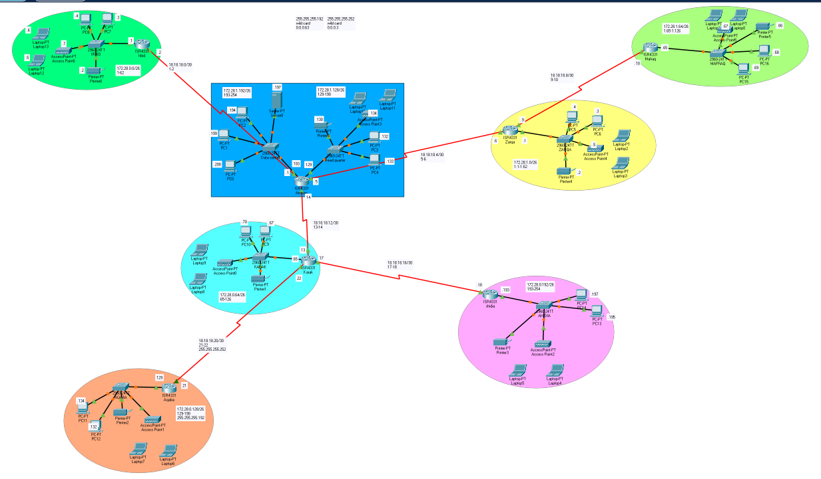

**b.part**

|  |  |  |  |
| --- | --- | --- | --- |
| **Network address** | **First host** | **Last host** | **broadcast** |
| 172.28.0.0/26 | 172.28.0.1 | 172.28.0.62 | 172.28.0.63 |
| 172.28.0.64/26 | 172.28.0.65 | 172.28.0.126 | 172.28.0.127 |
| 172.28.0.128/26 | 172.28.0.129 | 172.28.0.190 | 172.28.0.191 |
| 172.28.0.192/26 | 172.28.0.193 | 172.28.0.254 | 172.28.0.255 |
| 172.28.1.0/26 | 172.28.1.1 | 172.28.1.62 | 172.28.1.63 |
| 172.28.1.64/26 | 172.28.1.65 | 172.28.1.126 | 172.28.1.127 |
| 172.28.1.128/26 | 172.28.1.129 | 172.28.1.190 | 172.28.1.191 |
| 172.28.1.192/26 | 172.28.1.193 | 172.28.1.254 | 172.28.1.255 |
| 18.18.18.0/30 | 18.18.18.1 | 18.18.18.2 | 18.18.18.3 |
| 18.18.18.4/30 | 18.18.18.5 | 18.18.18.6 | 18.18.18.7 |
| 18.18.18.8/30 | 18.18.18.9 | 18.18.18.10 | 18.18.18.11 |
| 18.18.18.12/30 | 18.18.18.13 | 18.18.18.14 | 18.18.18.15 |
| 18.18.18.16/30 | 18.18.18.17 | 18.18.18.18 | 18.18.18.19 |
| 18.18.18.20/30 | 18.18.18.21 | 18.18.18.22 | 18.18.18.23 |

|  |  |
| --- | --- |
| **Device** | **IP configuration** |
| PC’s | DHCP |
| Laptop’s | DHCP |
| Printer’s | Static |
| server | Static |

|  |  |  |  |  |
| --- | --- | --- | --- | --- |
| **City name** | **network IP address** | **Subnet mask** | **Default gateway** | **Wild card** |
| Amman HQ | 172.28.1.128/26 | 255.255.255.192 | 172.28.1.129 | 0.0.0.63 |
| Amman DC | 172.28.1.192/26 | 255.255.255.192 | 172.28.1.193 | 0.0.0.63 |
| Irbid | 172.28.0.0/26 | 255.255.255.192 | 172.28.0.1 | 0.0.0.63 |
| Zarqa | 172.28.1.0/26 | 255.255.255.192 | 172.28.1.1 | 0.0.0.63 |
| Mafraq | 172.28.1.64/26 | 255.255.255.192 | 172.28.1.65 | 0.0.0.63 |
| Karaq | 172.28.0.64/26 | 255.255.255.192 | 172.28.0.65 | 0.0.0.63 |
| Shidia | 172.28.0.192/26 | 255.255.255.192 | 172.28.0.193 | 0.0.0.63 |
| Aqaba | 172.28.0.128/26 | 255.255.255.192 | 172.28.0.129 | 0.0.0.63 |

|  |  |  |  |
| --- | --- | --- | --- |
| **Router interfaces name** | **IP addresses** | **Protocols used** | **Passwords** |
| Amman Gig 0/0/0 | 172.28.1.129 | OSPF | Password: final |
| Amman Gig 0/0/1 | 172.28.1.193 | OSPF | Password: final |
| Amman Serial 0/1/1 | 18.18.18.5 | OSPF | Password: final |
| Amman Serial 0/2/0 | 18.18.18.14 | OSPF | Password: final |
| Amman Serial 0/1/0 | 18.18.18.1 | OSPF | Password: final |
| Zarqa Gig 0/0/0 | 172.28.1.1 | OSPF | Password: final |
| Zarqa Serial 0/1/0 | 18.18.18.9 | OSPF | Password: final |
| Zarqa Serial 0/1/1 | 18.18.18.6 | OSPF | Password: final |
| Mafraq Gig 0/0/0 | 172.28.1.65 | OSPF | Password: final |
| Mafraq Serial 0/1/0 | 18.18.18.10 | OSPF | Password: final |
| Irbid Gig 0/0/0 | 172.28.0.1 | OSPF | Password: final |
| Irbid Serial 0/1/0 | 18.18.18.2 | OSPF | Password: final |
| Karaq Gig 0/0/0 | 172.28.0.65 | OSPF | Password: final |
| Karaq Serial 0/1/0 | 18.18.18.22 | OSPF | Password: final |
| Karaq Serial 0/1/1 | 18.18.18.17 | OSPF | Password: final |
| Karaq Serial 0/2/0 | 18.18.18.13 | OSPF | Password: final |
| Shidia Gig 0/0/0 | 172.28.0.193 | OSPF | Password: final |
| Shidia Serial 0/1/1 | 18.18.18.18 | OSPF | Password: final |
| Aqaba Gig 0/0/0 | 172.28.0.129 | OSPF | Password: final |
| Aqaba Serial 0/1/0 | 18.18.18.21 | OSPF | Password: final |

**c.part**

|  |  |  |
| --- | --- | --- |
| **Services** | **Why to install** | **IP address** |
| DHCP | To assign IP address automatically for the devices | 172.28.1.197 |
| HTTP | Ask for site pages and transferring them between servers and programs. | 172.28.1.197 |
| Email | Sending mail between clients | 172.28.1.197 |
| DNS | Resolving internet names (URL) into IP address | 172.28.1.197 |
| FTP | File transferring between client and servers. | 172.28.1.197 |

**Configuration:**

**First the FTP service: I made username and password for each city, so each device in each city has the ability to write, read, delete, rename, or list files.**

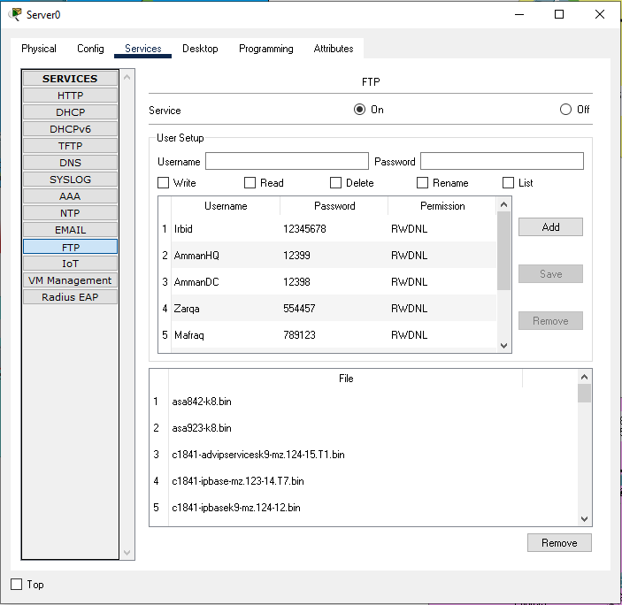

**Next is the DHCP service:**

I created the DHCP service for each city so now the IP address will be assigned automatically for each device in each city. The pool name for each city is the same as the city’s name.

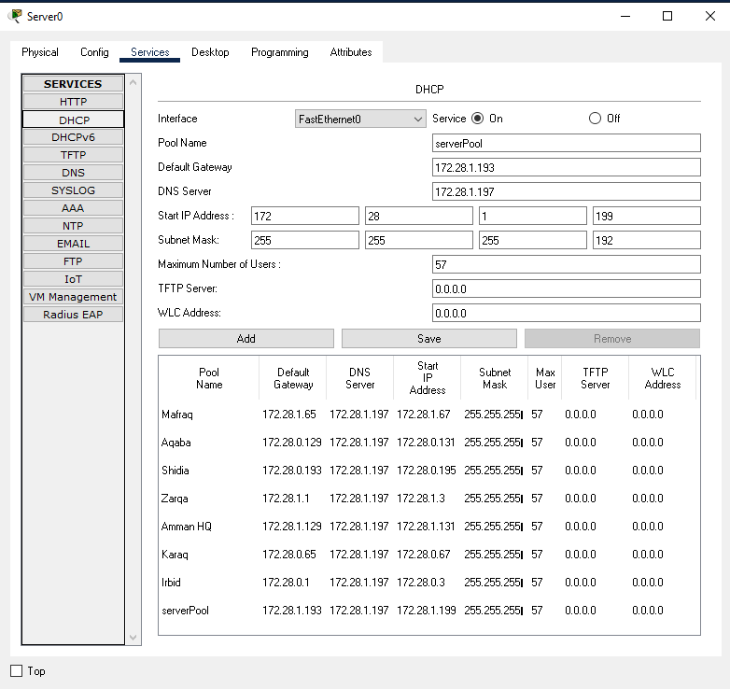

**Email service:**

The email service was made for each city for users to have the ability to send messages between each other, with the name of each city and its own password. Including the data center and the head quarter in Amman.

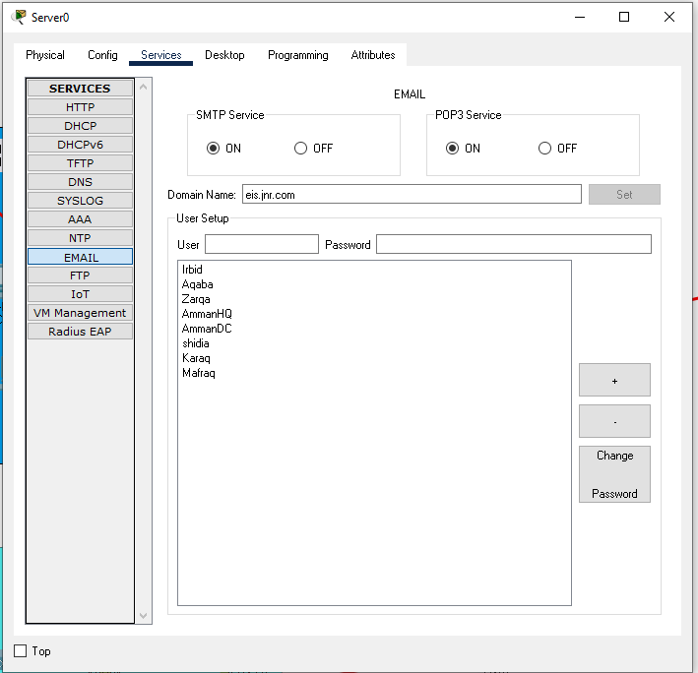

**The DNS and HTTPS services were included:**

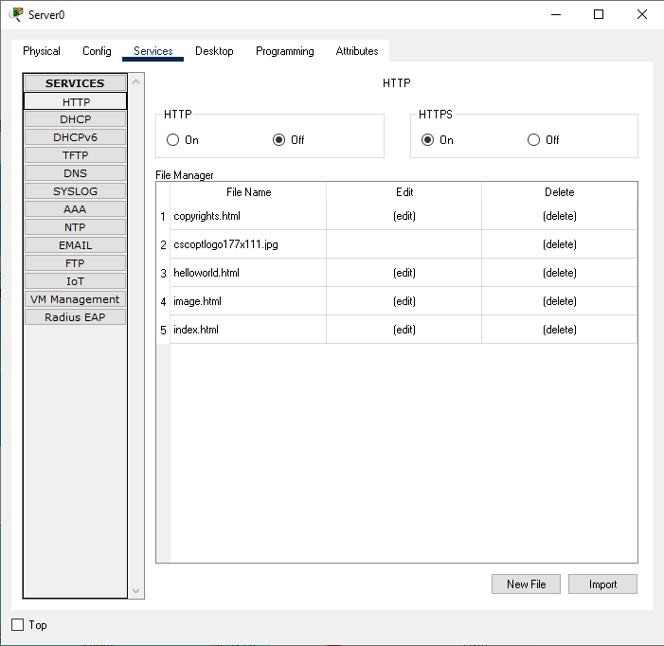

**And now all employees could access the company’s secure website.**

**2.**

**test plan:**

|  |  |  |
| --- | --- | --- |
| **What to test** | **How to test** | **Expected results** |
| Web-https | The IP address of the web server should be interred by the user in the URL in any device such as the laptop, Or the full qualified domain name which is https://eis.jnr.com.jo | The webpage should be loading successfully in the browser. |
| DHCP | Using any device such as the pc, we should go to desktop, then IP configuration then click on the DHCP. | An IP address should be generated automatically to the device. |
| DNS | Using any employees device, the browser should be opened and to type https://eis.jnr.com.jo | The webpage should be loading successfully in the browser. |
| Email | From any device in any city the user should send an email using the username and password that was given to it. | The emails should be delivered successfully to the other part. |
| FTP | Using the ftp command in any device following with the IP address of the server | A connected message should occur and the user name and password will be asked for the user to inter. |
| Routers | We could try binging the routers IP address from any device. Or we could just try sending packets or binging other devices in other networks that has a router between them. | All binging procedures or sending of packets should be successful. |
| subnets | We can check subnets by using Bing command from any device by typing ping and the IP address of the device that we want to check. | The Bing should be successful and replies should be sent to the device. |

3. maintenance schedule:

|  |  |  |  |  |  |  |
| --- | --- | --- | --- | --- | --- | --- |
| *Task* | daily | weekly | monthly | 3 months | 6 months | yearly |
| Exterior devices cleaning |  |  |  |  |  |  |
| Interior devices cleaning |  |  |  |  |  |  |
| Run anti-virus scanner |  |  |  |  |  |  |
| Data backup service |  |  |  |  |  |  |
| anti-virus updates |  |  |  |  |  |  |
| check connectivity between devices |  |  |  |  |  |  |
| Caples maintenance |  |  |  |  |  |  |
| devices maintenance |  |  |  |  |  |  |
| Remove unused, expired software |  |  |  |  |  |  |
| Check for motherboard BIOS updates |  |  |  |  |  |  |
| Clean all devices inside out |  |  |  |  |  |  |
| Monitoring devices temperature |  |  |  |  |  |  |

Part3:

2.Question

Checking connections between deices:

-PC11(Aqaba) and PC16(Mafraq) successful connection, the result shows that four packets were sent and four packets were received as expected.

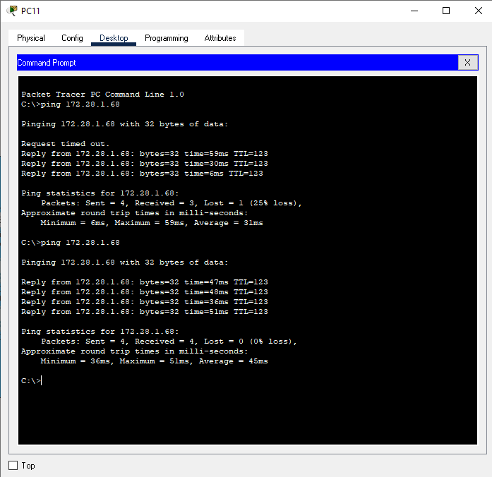

To assess the DNS server, I am going to use nslookup command in laptop 12 in Irbid. And It was successful as expected.

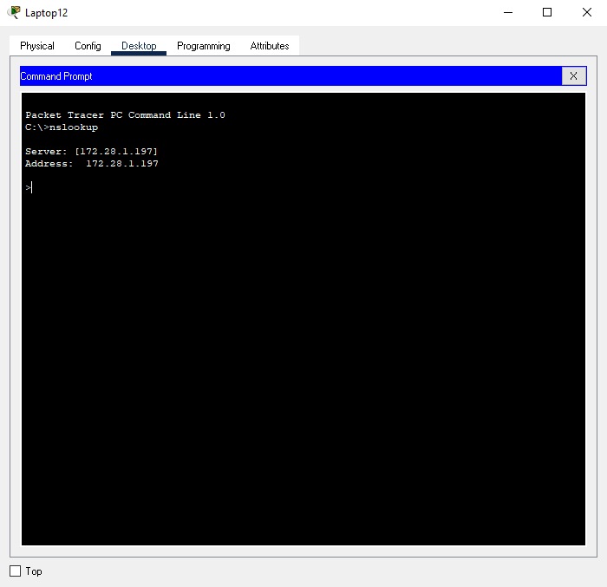

I used tracert command (trace route) to trace the sequence of hops that the packet is going to use in order to get to the destination, which is Mafraq LAN network. And the result was as expected.

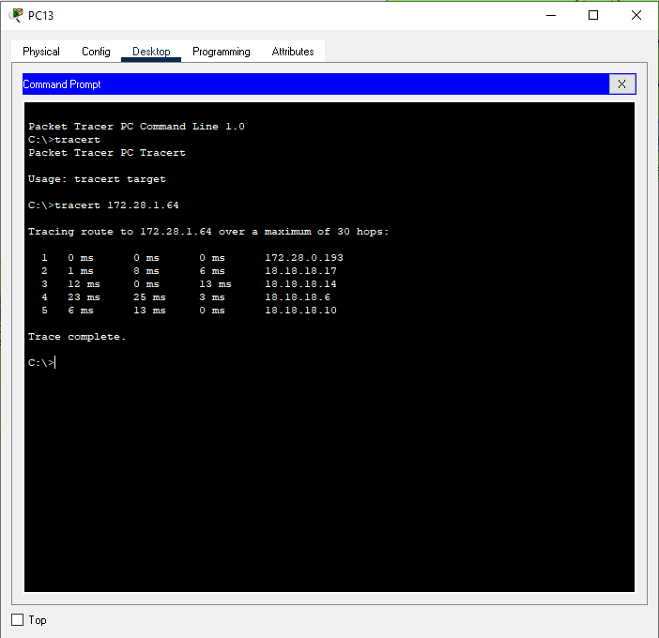

In order to know the default gateway and the IP address for PC3 in Amman HQ I am going to use IPCONFIG: and the results were as expected:

But to add the DNS server and the DHCP server I will use IPCONFIG/ALL

3.Question

FTP service:

Devices were successfully able to access the ftp service(PC14 in Shidia, laptop3 in Zarqa, PC5 in Zarqa).

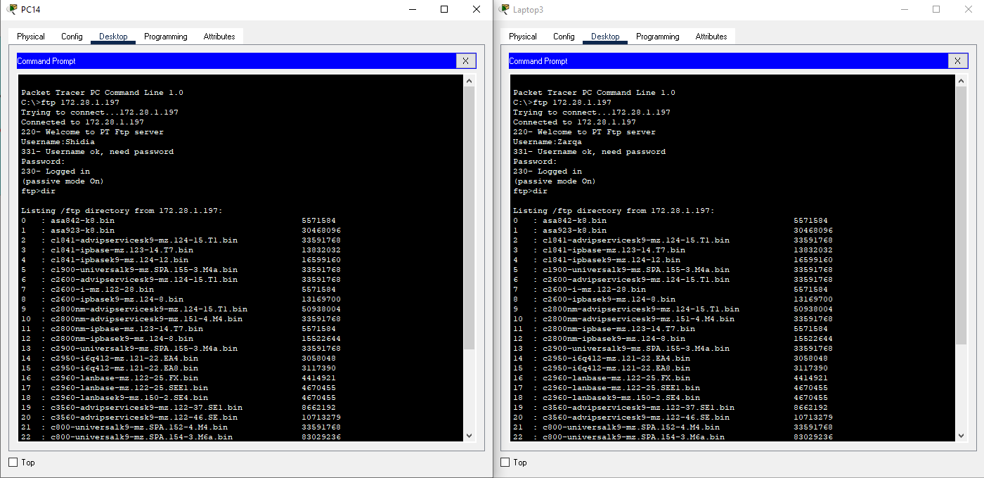

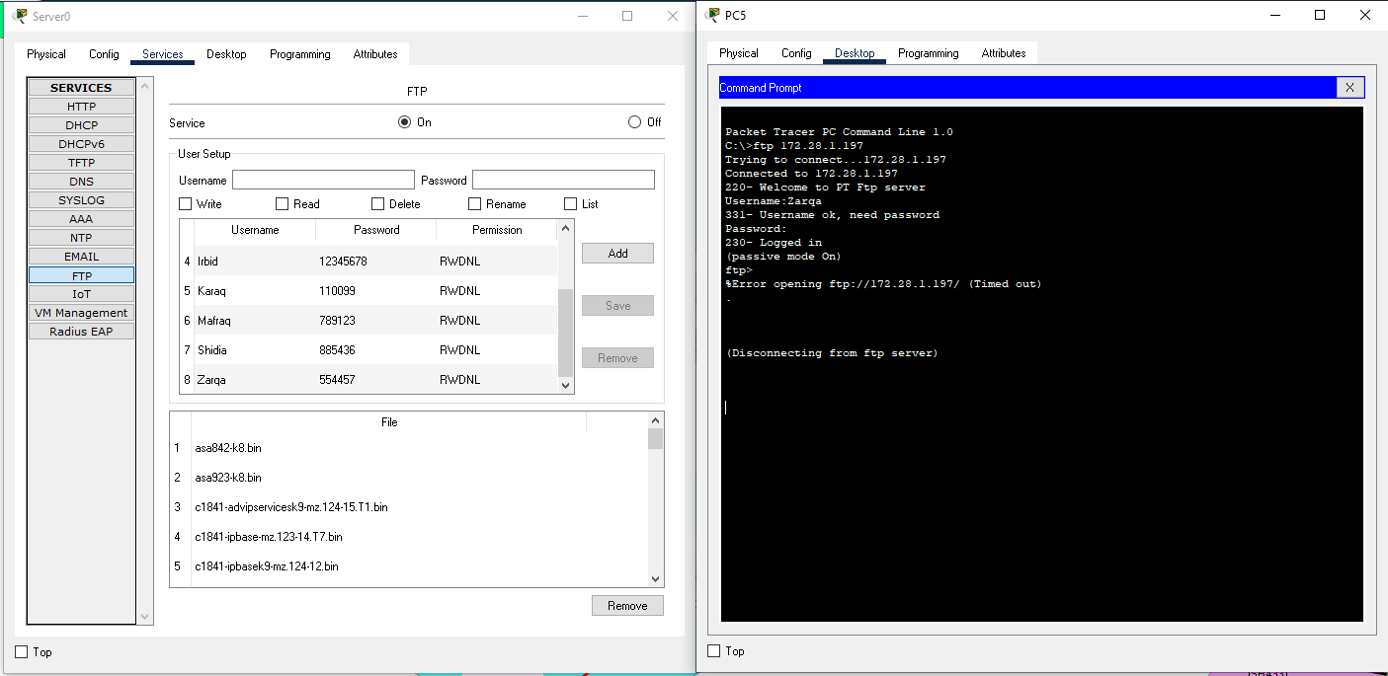

I also added a file with the name (project.txt) from pc5 using text editor first:

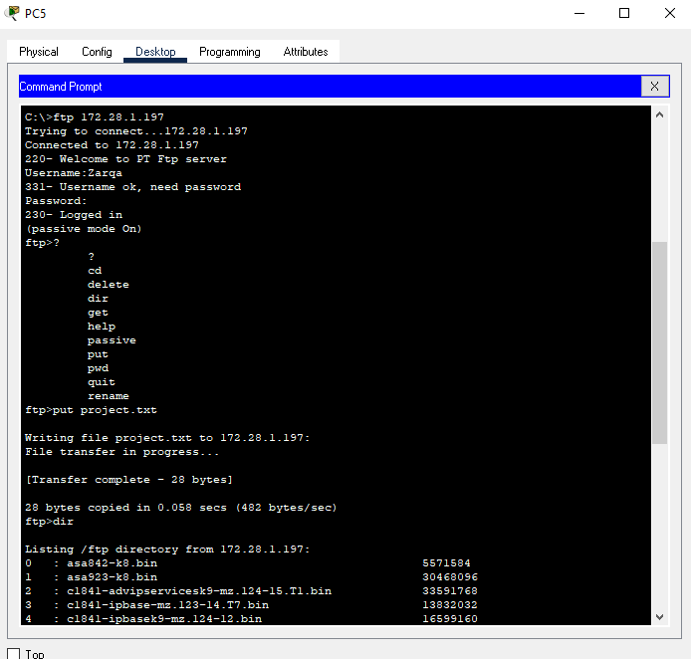

As shown above the file was added successfully in line 31.

**Email service:**

To test the email service, I am going to send an email from PC3 in Amman head quarter to laptop 6 in Aqaba:

First I need to configure PC3 and laptop 6 to send emails:

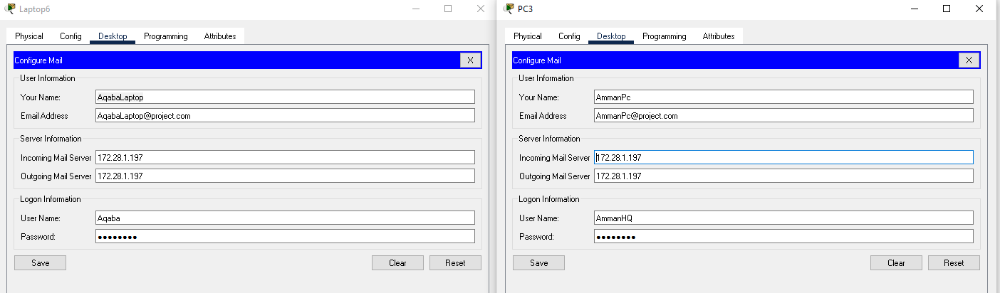

Then I will send an email from PC3 to laptop6:

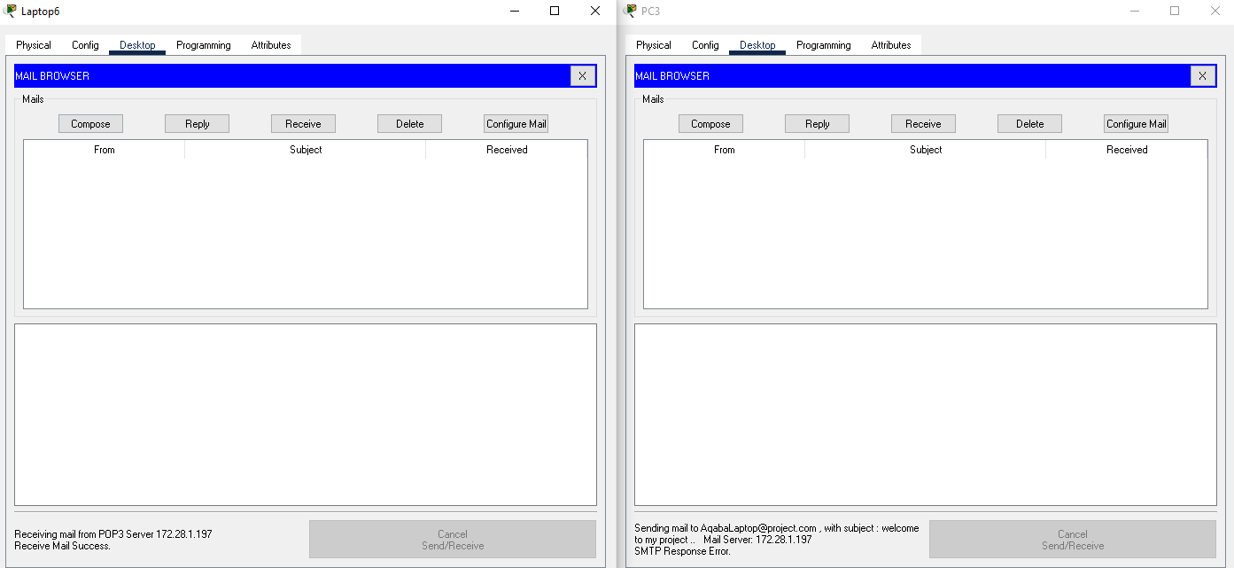

As shown above the email was sent successfully.

**DHCP service:**

In order to check if the DHCP service is working I would have to open the IP configuration in any device and look if the DHCP is working or not.

As expected the DHCP has given the PC above an IP address.

**DNS server:**

The name of the DNS server is ([www.eis.jnr.com.jo](http://www.eis.jnr.com.jo)) and its address is 172.28.1.197

**The web server:**

The web server is working successfully as expected and device are able to access the web page.

4.

**potential enhancements**

1. Using network monitoring tool:

A network monitoring tool helps you to find bugs on your devices more easily which would give your more time fixing it and less time searching for it. And this would help in productivity. Example: AppNeta Performance Manager.

1. I would prefer adding more cabling between routers which would help in having alternative paths for the packets to move through in case that a router has failed you do not want the whole system to be down.
2. Crating a network that is just for guests in order to limit the number of users on the network which will affect the overall performance of the network.

**functionalities to allow networking systems to support growth of devices and addition of communication devices:**

1. Having wi-fi access that would allow more devices to access the network easily without having to add more cables into the network.
2. Having extra subnets in the network that will also help in the growth of the networking. So, you can add more routers and more devices which will help in expanding the project and adding more branches to it.
3. Connecting the network into the internet which would help the network to exchange information with other networks around the world.

5.Question

* **significance of upgrades to a network**

1. to increase the network ability to manage more traffic. Traffic gets bigger every year due to the internet of things, cloud computing and other reasons.
2. To prevent your network of slowing down. For example, a wireless technology could be used to give more speed for the network and gives employees the ability to work from everywhere in the world at an amazing speed. And the old network infrastructure cannot manage this.
3. To give your employees better work environment you can use cloud computing in order to give them access to the network from any place and any time which will help with the productivity. And the old network infrastructure cannot manage this.
4. Upgrading the network infrastructures such as having new routers, switches, and wireless systems that comes with intelligent sensors will have better ability to prevent hackers from accessing your network.
5. Upgrading the network hardware will help the network to run heavy applications that old networks cannot run them so you would prevent any crashes of occurring on the network while using this application. Adding to that any business will need to run heavy applications.

* **significance of security to a network**

1. Keeping data safe

When data becomes available for anyone to reach, this will affect your privacy and having to face losing valuable information from your device.

1. Saving money

Having a secure network will prevent you of dealing with the consequence of having unauthorized access and losing information. Which sometimes might cost the company’s millions of dollars, and not all companies can survive this which will lead to end its work.

1. Developing your company

The main focus of any company is to accomplish its tasks and to do its job, and this cant happen if the company had loopholes in its systems that any cyber criminal could take advantage of. Which will cause the company to focus on fixing this problem and delaying their tasks which will later on affect reaching their goals.

1. Having good reputation for your company

Applying the latest technologies for security will ensures high-quality service which will affect your company’s reputation and staying in the top. But getting cyber-attack might be the end of your reputation.

**6.Question**

* **Evaluation of my own work:**

In the bigging of the project it was a bit hard to organize the steps in which to start with.

I started subnetting the main subnet which I did not find difficult. Then I wrote the subnetting result and I started giving each LAN network it own IP address and their ranges with all the other information such as, the wild card, subnet mask In order to make the designing much easier.

For the routing protocol I find it better to use OSPF for the following reasoning:

* It is a classless routing protocol
* Its administrative distance is 110
* Uses multicast
* better to use for big projects

Using Packet Tracer Simulator, I made a LAN network for each city and divided the IP address on them and divided routers between them and added password for each router to prevent unauthorized access. And I made one serial cable between each router, but I think it would be better if I connect each router with multiple routers instead of just one router to have alternative paths in case of any failures.

In conclusion, I believe that this project has improved my understanding of networking and the way that connections happen between devices and the way we connect the devices either wired or wirelessly. Also, it had made me understand more of the way the servers work and how we use them and the way that routers understand how to select the best path for a packet.

References:

[What is Network Topology? Best Guide to Types & Diagrams - DNSstuff](https://www.dnsstuff.com/what-is-network-topology)

[Physical Topology | Learn Top 7 Useful Types Of Physical Topology (educba.com)](https://www.educba.com/physical-topology/)

[Networkingsem 32 - This assignment talks about networking and equipment used when designing a - StuDocu](https://www.studocu.com/en-gb/document/university-of-sunderland/network-design/networkingsem-32-this-assignment-talks-about-networking-and-equipment-used-when-designing-a-network/12541221)hardware specification selection

[Importance of Network Security: Staying on Top of IT — ITcompanies.net](https://itcompanies.net/blog/network-security-importance)

[Physical vs Logical Topologies - Bing video](https://www.bing.com/videos/search?q=logical+topology+protocol&ru=%2fvideos%2fsearch%3fq%3dlogical%2btopology%2bprotocol%26FORM%3dHDRSC4&view=detail&mid=294EB7840AE36D0375AB294EB7840AE36D0375AB&&FORM=VDRVRV)

[Protocols Per Layer - Automation Admin](https://automationadmin.com/2016/05/protocols-per-layer/)

[TCP vs. UDP: What’s the Difference? - Lifesize](https://www.lifesize.com/en/blog/tcp-vs-udp/)

[What is Ethernet? | Ethernet Devices & Uses | RealPars](https://realpars.com/ethernet/)

[Importance of Network Security: Staying on Top of IT — ITcompanies.net](https://itcompanies.net/blog/network-security-importance)

[6 Reasons to Upgrade Your Network Infrastructure for the Growth of IoT (1000gig.com)](https://1000gig.com/reasons-your-network-infrastructure-needs-an-upgrade/#:~:text=One%20of%20the%20biggest%20reasons%20to%20go%20for,is%20robust%20and%20modern%20to%20run%20advanced%20applications.)

[Expanding the Network (System Administration Guide, Volume 3) (oracle.com)](https://docs.oracle.com/cd/E19455-01/806-0916/ns-ov-6/index.html#:~:text=Expanding%20the%20Network%20The%20longer%20a%20network%20is,expanding%20network%20services%20by%20providing%20additional%20shared%20software.)

**Student Assessment Submission and Declaration**

When submitting evidence for assessment, each student must sign a declaration confirming that the work is their own.

|  |  |  |
| --- | --- | --- |
| Student name: Yousef Abu Ali  Student ID: 21110294  Is the student repeating the unit?  Yes  No | | Assessor name:  Dr. Huthaifa Al Omari  Eng. Sami Mashaqbeh |
| Issue date:  03/8/2022 | Submission date:  03/09/2022 | Submitted on:  02/09/2022 |
| Programme: Computing | | |
| HTU Course Name: Networking BTEC Course name: Networking  HTU Course Code: 30201110 BTEC Course Code: H/615/1619 | | |
| Assignment number and title: Assignment 11: JNR. | | |

**Plagiarism**

Plagiarism is a particular form of cheating. Plagiarism must be avoided at all costs and students who break the rules, however innocently, may be penalized. It is your responsibility to ensure that you understand correct referencing practices. As a university level student, you are expected to use appropriate references throughout and keep carefully detailed notes of all your sources of materials for material you have used in your work, including any material downloaded from the Internet. Please consult the relevant unit lecturer or your course tutor if you need any further advice.

|  |
| --- |
| Student declaration  I certify that the assignment submission is entirely my own work and I fully understand the consequences of plagiarism. I understand that making a false declaration is a form of malpractice.  Student signature: Date: 02/9/2022 |